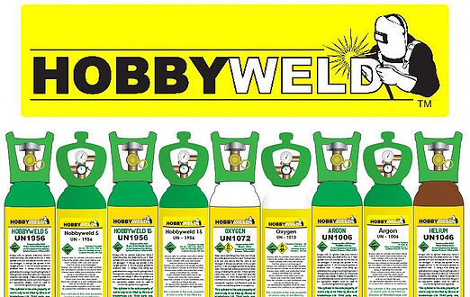

**Price List**

**9 Litre** **20 Litre**

Hobbyweld 5 (137 bar) **€57** Hobbyweld Plus (200 bar) **€110**

Argon (137 bar) **€78** Argon Plus (200 bar) **€155**

Nitrogen (137 bar) **€57** Oxygen (200 bar) **€110**

CO2 (Food Grade) (137 bar) **€57**

Oxygen (137 bar) **€57** Cylinder Deposit **€170**

Cylinder Deposit **€95**

**Deposits refundable less €15 Hobbyweld administration charge.**

**All prices listed include VAT at 23% (no VAT charged on cylinder deposits)**

 Bercar Welding Ltd.,

Unit 3, Kilmallock Road Enterprise Centre,

Kilmallock, Road, Limerick, V94 EC6N

Tel: 061-310259 Email: sales@bercar.com