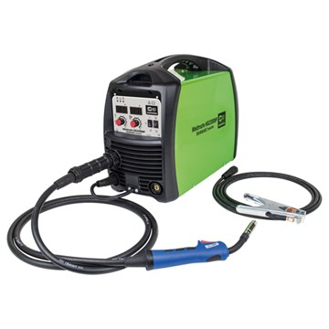

Weldmate HG2300MP MIG/ARC/TIG Inverter Welder
- 230v (16amp) supply
- Hi-tech Inverter Technology
- Low current performance
- Multifunctional 3-in-1 machine
- MIG/TIG/ARC weld
- Solid / Flux cored Wire Type
- Dinse sockets
- Lightweight, portable machine
- Complete with a 3m MB15 Mig torch, 3m earth cable with earth clamp, gas hose and gas clamp, Hand held face mask, Chipping hammer, 0.2Kg 0.8mm flux core wire, 0.6, 0.9 & 1.0mm contact tip
- 2 Year Warranty

Technical Description:
ITEM NO. | 05773
Supply | 230v (16amp)
 | MIG
Welding Current | 30amp to 200amp
Duty Cycle @ 20° | 200amps @ 50%
Duty Cycle @ 40° | 200amps @ 20%
Open Circuit Voltage | 15.5v to 24v
Wire Size | 0.6mm / 1mm
Wire Spool Size | 0.7kg - 5kg
Approx. Weld Thickness Range
 | ARC
Welding Current | 30amp to 170amp
Duty Cycle @ 20° | 200amps @ 50%
Duty Cycle @ 40° | 200amps @ 20%
Electrode Size | 1.6mm to 4mm
Open Circuit Voltage | 21.2v to 26.8v
Approx. Weld Thickness Range | 1.0mm to 7.0mm
 | TIG
Welding Current | 20amp to 200amp
Duty Cycle @ 20° | 200amps @ 50%
Duty Cycle @ 40° | 200amps @ 20%
Electrode Size | 0.5mm to 2.4mm
Insulation Class | H
Protection

